1. What is the output of the following addition (+) operator

a = [10, 20]

b = a

b += [30, 40]

print(a)

print(b)

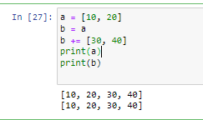

1. What is the output of print(2%6)
2. ValueError
3. 0.33
4. 2

* **Answer: -** c is correct – 2

1. What is the output of the following code:

print(bool(0), bool(3.14159), bool(-3), bool(1.0+1j))

1. True True False True
2. False True True True
3. True True False True
4. False True False True

* **Answer: -**



1. What is the output of the expression  print(-18 // 4) ?

* **Answer: -**

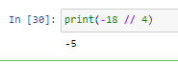

1. What is the output of print(2 ** 3 ** 2) ?

* **Answer: -**



1. 4 is 100 in binary and 11 is 1011. What is the output of the following bitwise operators?

a = 4

b = 11

print(a | b)

print(a >> 2)

* **Answer: -**

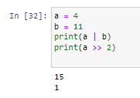

1. What is the value of the following Python Expression

print(36 / 4)

* **Answer: -**



1. What is the output of the following assignment operator

y = 10

x = y += 2

print(x)

* **Answer: -**

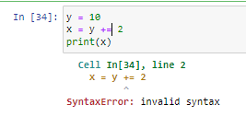

1. What is the output of print(2 * 3 ** 3 * 4)

* **Answer: -**

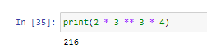

1. Which of the following operators has the highest precedence?

* **Answer: -**

Parentheses ‘()’ have the highest precedence in python followed by the Exponents ‘**’.

1. What is the output of print(10 - 4 * 2) ?

* **Answer: -**

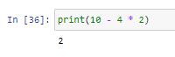

1. What is the output of the following code:

x = 6

y = 2

print(x ** y)

print(x // y)

* **Answer: -**

